How to add devices into blacklist
Step 1: Open the browser and input plc.tendawifi.com in address bar to login setup page. By default, password is “admin”.
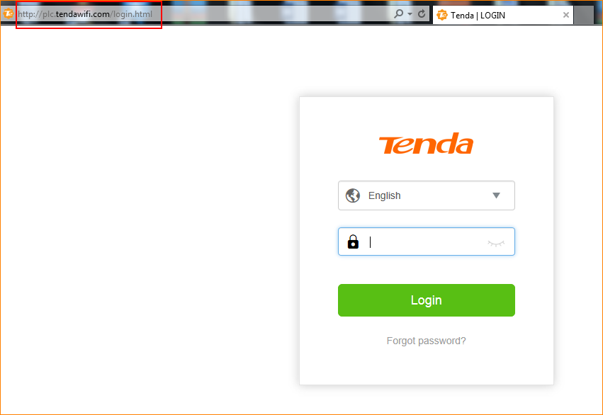

Step 2: Choose “Internet Status” > “Attached Devices”.

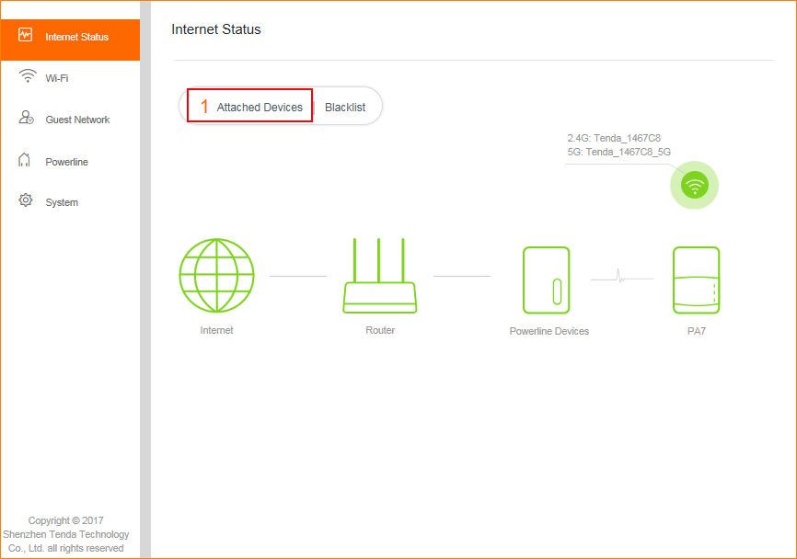
Step 3: Tap “Add”, device will be added into blacklist.
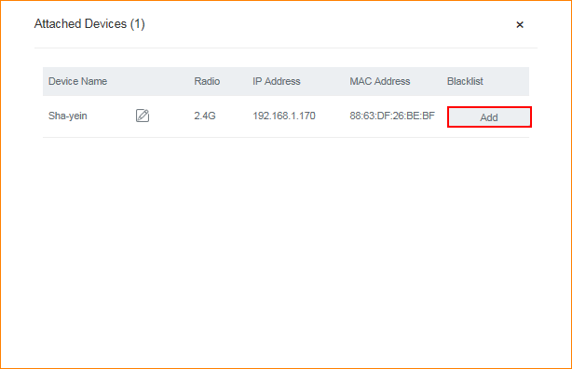
Step 3: Tap “Blacklist” to check the devices you added into blacklist.
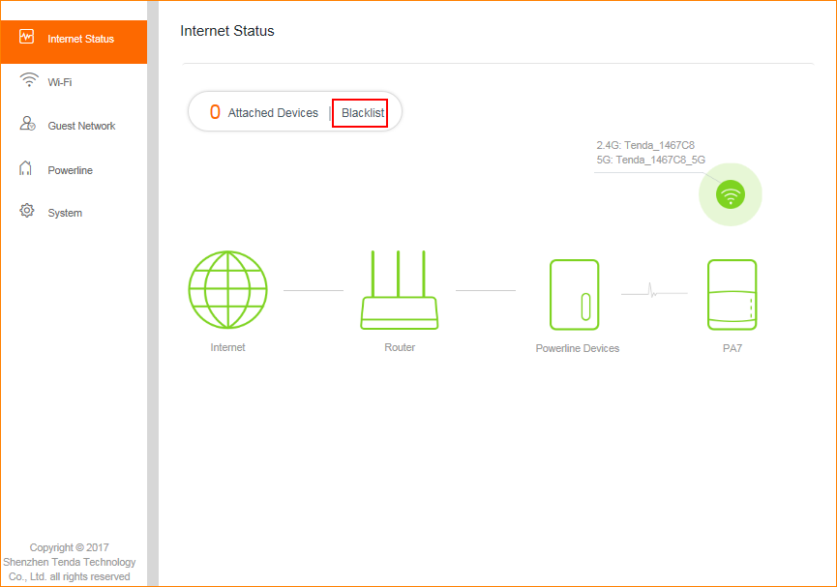

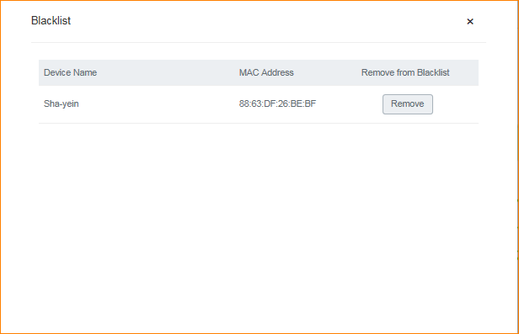
Step 4: If you want to remove device in blacklist, just tap “Remove”.
